Inventory Tracker System
Overview
The Inventory Tracker System is a simple, console-based Python application designed to help users manage and monitor inventory items efficiently. It allows users to add items, view inventory details, search for specific products, and store inventory data permanently using file handling.
Problem Addressed
Managing inventory manually can lead to stock shortages, overstocking, data errors, and lack of record persistence. This project provides a basic digital solution for organizing inventory data efficiently.
Main Features
- Add Inventory Item – Adds new inventory records with item details.
- View Inventory – Shows all available inventory items.
- Search Inventory by Item ID – Finds a specific item using its unique ID.
- Menu-driven Interface – Allows users to choose operations through a menu.
- Input Validation – Prevents incorrect inputs and handles errors safely.
- Data Persistence – Stores inventory data in a file for future use.
Python Concepts Used
Data Structures:
- Dictionary – Used to store inventory data with keys representing item attributes.
- Lists – Used as values inside the dictionary to hold multiple inventory records.
- Dictionary of Lists Structure – Each list index represents a single inventory item across all fields.
- Efficient Data Management – Enables easy addition, searching, and deletion of inventory records.
Control Flow:
- While Loop – Used to repeatedly display the menu until the user chooses to exit.
- If / Elif / Else Statements – Used to handle menu selection and decision-making logic.
- For Loop – Used to iterate through inventory records for viewing and searching items.
Functions:
- Show_menu() – Displays the main menu options to the user.
- Add_item() – Adds a new item to the inventory.
- View_inventory() – Displays all inventory records.
- Search_item() – Searches for an inventory item using Item ID.
- Delete_item() – Removes an item from the inventory.
- Save_to_file() – Saves inventory data to a file.
- Load_from_file() – Loads inventory data from a file at program start.
- Exit_program() – Exits the program safely after saving data.
Methods
List Methods
- append() – Used to add new inventory records to the list.
- pop() – Used to remove inventory records from the list.
- len() – Used to determine the number of inventory items.
Dictionary Methods
- keys() – Used to access all dictionary keys.
- values() – Used to access all dictionary values.
- get() – Used to safely retrieve values from the dictionary.
String Methods
- strip() – Used to remove extra spaces from user input.
- title() – Used to format item names properly.
Exception Handling
- try/except Block – Used to handle invalid user input such as entering text instead of numbers.
- ValueError Handling – Prevents the program from crashing due to incorrect data types.
- User-Friendly Messages – Displays clear error messages when an exception occurs.
- Smooth Program Execution – Ensures the program continues running even after input errors.
File Handling and Libraries
- File Handling – Inventory data is saved to and loaded from a file using the with open() statement.
- Read and Write Operations – Files are opened in read ("r") and write ("w") modes to manage data persistence.
- Data Persistence – Ensures inventory records are retained after program execution ends.
- Libraries Used – Standard Python libraries are used, without any external dependencies.

How to Run
1. Open Jupyter Notebook or Python environment.
2. Run the inventory tracker file.
3. Run all cells or the main program cell.
4. Follow menu instructions.
Input and Usage Guidelines
- Numeric Inputs – Item ID, Quantity, and Unit Price must be entered as numbers only.
- Text Inputs – Item Name and Category should be entered as text.
- Menu Selection – Users must select menu options using the corresponding numbers.
- Invalid Input Handling – The program displays an error message if incorrect input is entered.
- Exit Procedure – Users should choose the exit option to safely close the program and save data.
File and Dataset Details
- Data File Name – Inventory Tracking System is stored in a file named inventory.txt.
- File Location – The data file is stored in the same folder as the Python program.
- Stored Fields – Item ID, Item Name, Category, Quantity, and Unit Price.
- File Creation – If the file does not exist, it is created automatically when data is saved.
- Data Loading – Inventory data is loaded from the file when the program starts.

Testing and Screenshots
Useful test scenarios:
- Viewing all inventory.

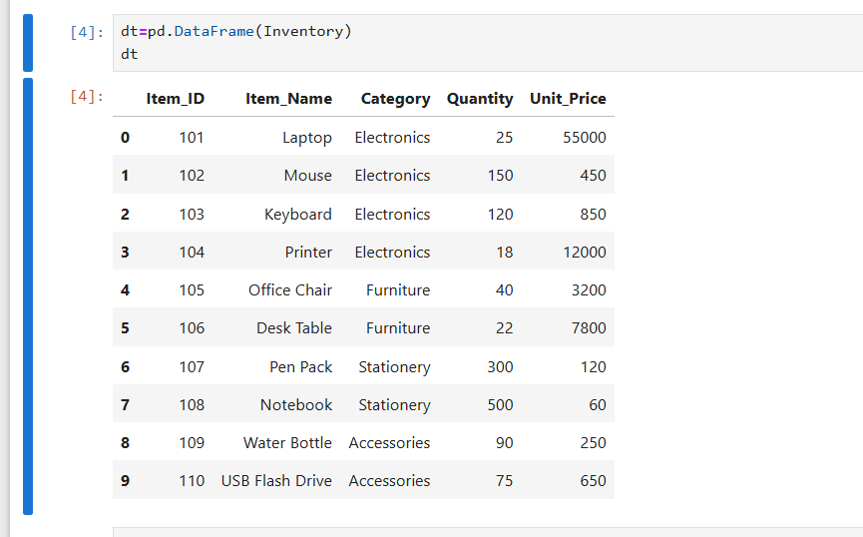
- Adding the item
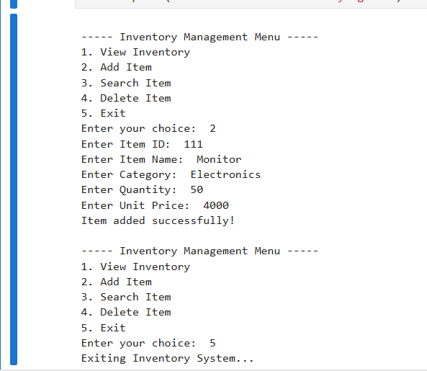

- Searching the item
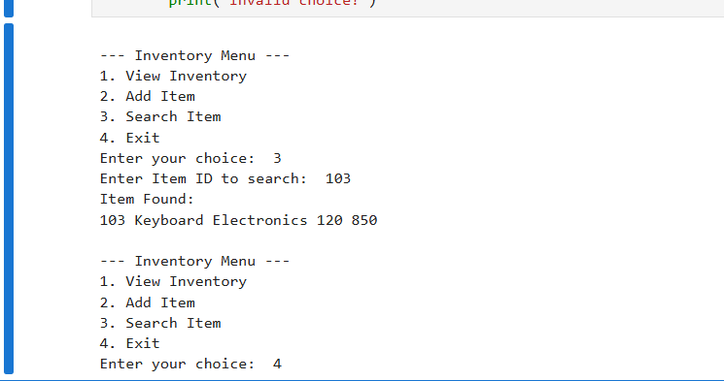
- Entering only numbers
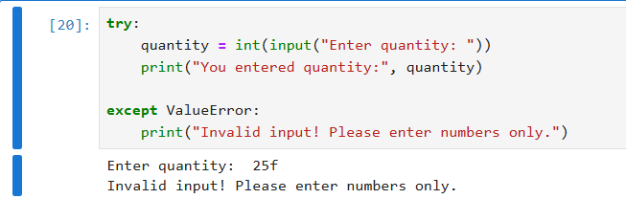
Assignment Fit and Extras
- Meets Assignment Requirements – Fully satisfies all Python mini-project guidelines.
- Real-World Application – Addresses a practical problem in inventory management.
- Structured Programming – Uses functions, loops, and conditionals effectively.
- Error Handling – Includes exception handling to manage invalid inputs.
- Data Persistence – Implements file handling to save and load inventory data.
- Easy to Extend – Can be enhanced with additional features if required.

- Name: Sumanth Nayak
- USN: 1BG24BA133
- Course: Python Programming
- Project: Inventory Tracking System
- Domain: Inventory / Retail Management

